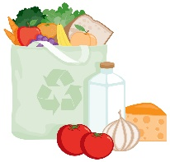
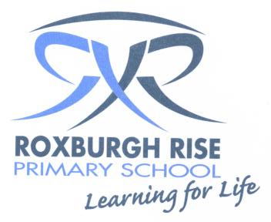
Year 5 Term 3 Overview 2017

Dear Parent/Guardians,

Please find an outline of the grade 5 teaching and learning programs for Term 3. Due to the wide range of student abilities in each classroom, the teaching and learning program will be structured so that the learning needs of each student are catered for. Students will also be using their tablets to deepen their understanding of concepts, raise engagement levels and support personalised learning through all areas of the curriculum.

English: | Reading sessions will involve a variety of learning experiences related to a range of texts. Students will be grouped with other students of like needs. Students will be exposed to effective comprehension strategies that help them to analyse information, integrate and link ideas from a variety of print and digital sources. Some of these include:
 | - Facts and details  - Word meaning in context  - Paraphrasing information |  | - Main idea  - Author’s purpose  - Summarising information
 | Writing sessions will concentrate on the processes of Planning, Composing/Recording, Revising and Publishing their writing during Writer’s Notebook sessions. They will also be learning about the structure of information reports and will have a go at writing some based on our health topic.
Speaking & Listening will be a daily event in the classroom during sharing/reflection sessions. Students will be provided with opportunities to learn about and practice using formal and non-formal language.

Students will also be presenting their homework and health projects to an audience of their choice at the end of the term.
 | Spelling is a part of the writing process. Students are exposed to a word wall which incorporates Inquiry Unit topic words. Spelling skills and strategies will be developed through spelling investigations each week which will focus on the student’s needs. We will particularly be focusing on sentence structure and the correct use of punctuation.
Mathematics: | Number:  - Multiplication  - Division  - Worded problem | Measurement and Geometry:  - Measurment  - Area |  | Statistics and Probability:  - Data Collection and Analysis for our Inquiry Topic
Inquiry Learning: | When learning about Health, we will focus on the following:  - What is healthy living, what life style choices we can make to ensure we are healthy and the life style choices that can prevent us from being healthy  - How the ‘Australian Guide to Healthy Eating’ and the information on food packaging can assist them with their food choice and how to safely and hygienically prepare/store food  - Puberty  - Prescription and non-prescription drugs  In Science students will be learning about Chemical science, where we will be focusing on the following:  - Properties of solids, liquids and gases  - The ways solids, liqids and gases behave
Social & Emotional Learning | Social and emotional learning is incorporated into our day to day program. Students will be involved in mindfulness, meditation and confidence building activities throughout the term.
Homework | - Two Week Topic - Students are to create a project about themselves using the weekly topics as a guide. They are to present their project about ‘Me, Myself and I’ to the class at the end of the term.  - Reading - Students to read a book for 20 minutes each night and record the title, pages read and a parent signature in their diary.  - Maths - Students to practise their multiplication and division facts that they are working on each night.  - Writing - Students to complete one page of their MacWrite book each week.

Kind regards,
Year 5 Teachers

Maria Michael, Sarah Wilkinson, Sarah Carroll, Lauren Walker, Brooke Paterno, Con Corso & Kim Carroll

